SCHOOL

Year 12 Trial WACE Examination, 2013

Question/Answer Booklet

MATHEMATICS 2C/2D
SOLUTIONS

Section Two:

Calculator-assumed

Student Number: In figures

In words

Your name

Time allowed for this section
Reading time before commencing work: ten minutes
Working time for this section: one hundred minutes

Materials required/recommended for this section

To be provided by the supervisor
This Question/Answer Booklet
Formula Sheet (retained from Section One)

To be provided by the candidate
Standard items: pens, pencils, pencil sharpener, eraser, correction fluid/tape, ruler, highlighters

Special items: drawing instruments, templates, notes on two unfolded sheets of A4 paper, and up to three calculators satisfying the conditions set by the Curriculum Council for this examination.

Important note to candidates

No other items may be used in this section of the examination. It is your responsibility to ensure that you do not have any unauthorised notes or other items of a non-personal nature in the examination room. If you have any unauthorised material with you, hand it to the supervisor before reading any further.

Structure of this paper

Section | Number of questions available | Number of questions to be answered | Working time (minutes) | Marks available | Percentage of exam
Section One:  Calculator-free | 6 | 6 | 50 | 50 | 33
Section Two:  Calculator-assumed | 12 | 12 | 100 | 100 | 67
 |  |  | Total | 150 | 100

Instructions to candidates

- The rules for the conduct of Western Australian external examinations are detailed in the Year 12 Information Handbook 2013. Sitting this examination implies that you agree to abide by these rules.

- Write your answers in the spaces provided in this Question/Answer Booklet. Spare pages are included at the end of this booklet. They can be used for planning your responses and/or as additional space if required to continue an answer.
- Planning: If you use the spare pages for planning, indicate this clearly at the top of the page.
- Continuing an answer: If you need to use the space to continue an answer, indicate in the original answer space where the answer is continued, i.e. give the page number. Fill in the number of the question(s) that you are continuing to answer at the top of the page.

- Show all your working clearly. Your working should be in sufficient detail to allow your answers to be checked readily and for marks to be awarded for reasoning. Incorrect answers given without supporting reasoning cannot be allocated any marks. For any question or part question worth more than two marks, valid working or justification is required to receive full marks. If you repeat an answer to any question, ensure that you cancel the answer you do not wish to have marked.

- It is recommended that you do not use pencil, except in diagrams.

Section Two: Calculator-assumed (100 Marks)
This section has twelve (12) questions. Answer all questions. Write your answers in the spaces provided.

Working time for this section is 100 minutes.

Question 7 (4 marks)
The variables 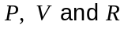 are related by the formula 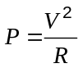.

(a) Determine the value of when 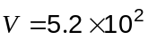 and 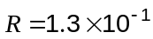, writing your answer in scientific notation. (2 marks)

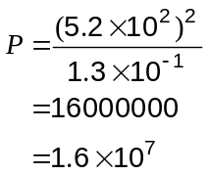

(b) Calculate the value of when 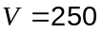 and 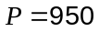, writing your answer to three significant figures. (2 marks)

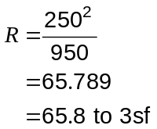

Question 8 (9 marks)
A public opinion survey investigated the relationship between age and support for increasing tax rates, with results summarised in the table below.

Age | 16 - 29 | 30 - 44 | 45 - 59 | 60 or older | Total
For | 18 | 44 | 43 | 32 | 137
Against | 74 | 59 | 44 | 39 | 216
No Opinion | 3 | 19 | 20 | 12 | 54
Total | 95 | 122 | 107 | 83 | 407

(a) One person is chosen at random from those surveyed. Determine the probability that this person

(i) has no opinion on increasing tax rates. (1 mark)
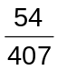

(ii) is aged between 30 and 44 and is against increasing tax rates. (1 mark)
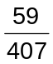

(iii) is aged between 16 and 29 or supports increasing tax rates. (1 mark)
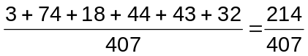

(b) One person is chosen at random from those supporting increasing tax rates. Determine the probability that this person is aged 30 or older. (2 marks)
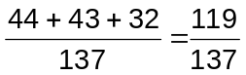

(c) One person is chosen at random from those aged under 60. Determine the probability that this person is against or has no opinion on increasing tax rates. (2 marks)
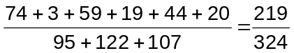

(d) If a larger sample of 1500 people were surveyed, how many of those aged between 45 and 59 would you expect to be against increasing tax rates? (2 marks)
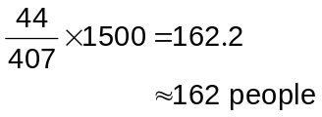

Question 9 (10 marks)
The daily rainfall, in millimetres, recorded by a weather station over a period of 21 days was a follows:

11, 0, 0, 17, 16, 12, 0, 0, 0, 2, 21, 6, 0, 0, 0, 0, 0, 1, 5, 4, 6

(a) State the mode, median and range of this data. (3 marks)
Mode is 0

Median is 1

Range is 21

(b) Calculate the mean and standard deviation for these 21 values. (2 marks)
Mean is 4.81

SD is 6.49

(c) Use the data to complete the frequency table below. (2 marks)

Rainfall (mm) | Frequency
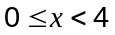 | 12
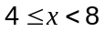 | 4
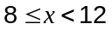 | 1
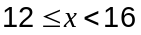 | 1
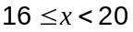 | 2
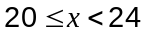 | 1

(d) Re-calculate the mean and standard deviation using the frequency table. (2 marks)
Mean is 6.19

SD is 6.23

(e) Explain why the mean from (d) is much higher than the mean from (b). (1 mark)
Most of the values in the 0 to 4 mm group of the frequency table were zeroes, but in calculating the mean they were assumed to be 2's.

Question 10 (8 marks)
In a class of 29 students, 5 of the boys did not play hockey and 6 of the 14 girls did.

(a) Use this information to complete all regions of the Venn diagram below, where H represents the set of hockey players and G is the set of girls. (3 marks)
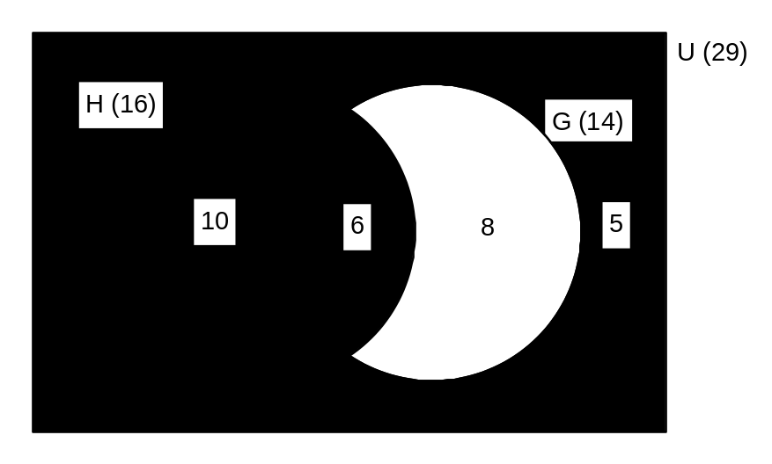

(b) State 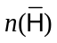. (1 mark)
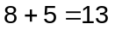

(c) Shade the region 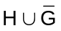 on the diagram above. (1 mark)

(d) If one of the students is selected at random, determine

(i) 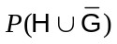. (1 mark)
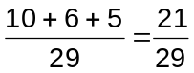

(ii) 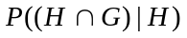. (2 marks)
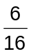

Question 11 (9 marks)
The height, metres, above level ground of a model helicopter during a 20 second period was modelled by the function 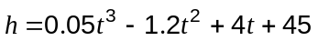, for 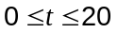 seconds.

(a) Calculate the height of the helicopter when 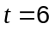. (1 mark)
36.6 metres

(b) Sketch the height function on the axes below. (4 marks)
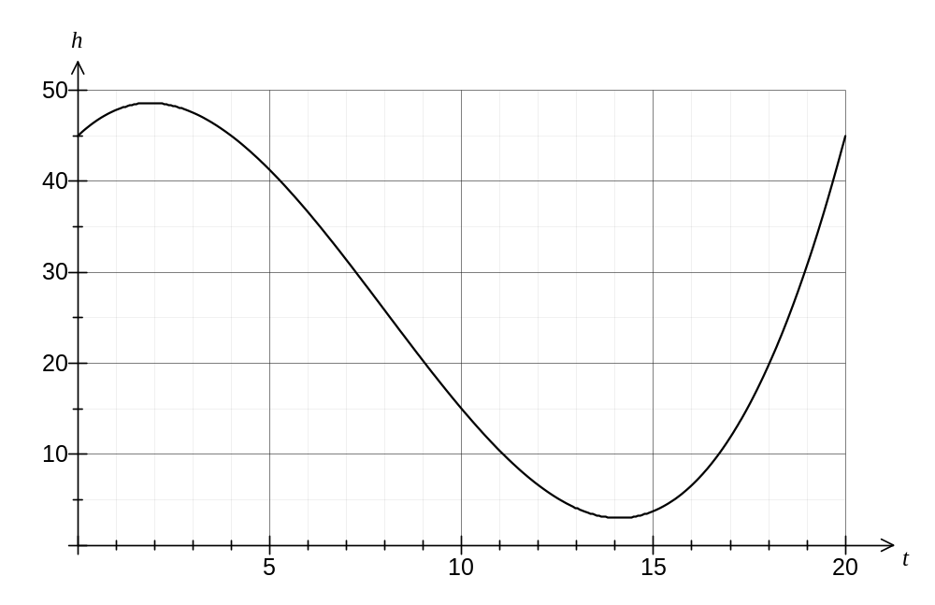
(c) What was the difference between the highest and lowest height reached by the helicopter in this 20 second period? (2 marks)
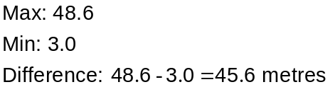

(d) At what time(s), to the nearest second, was the helicopter at a height of 30 m? (2 marks)

When

Question 12 (11 marks)
The distribution of ages of people under 30 who live in Western Australia is summarised in the table and histogram below. The mean of this data is 14.9 and the standard deviation is 8.66 years.

Age | Number of people | Relative frequency (%) | 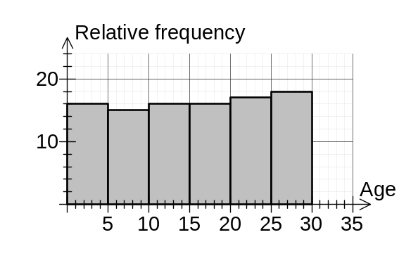
0 - 4 | 151 262 | 16.5
5 - 9 | 142 774 | 15.6
10 - 14 | 146 035 | 16.0
15 - 19 | 148 208 | 16.2
20 - 24 | 159 010 | 17.4
25 - 29 | 167 944 | 18.3
Total | 915 233 | 100.0

(a) Write down the calculation that would give the relative frequency for the 10 - 14 age group.
(1 mark)
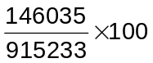

(b) State which is the modal class. (1 mark)

25 - 29 years

(c) Describe the spread of this data. (1 mark)

The ages are spread out fairly evenly across all the age groups

The distribution of ages of people under 30 who live in the West Perth suburb of Western Australia is summarised in the table below.

Age | Number of people | Relative frequency (%)
0 - 4 | 152 | 7.4
5 - 9 | 76 | 3.7
10 - 14 | 85 | 4.1
15 - 19 | 135 | 6.6
20 - 24 | 571 | 27.7
25 - 29 | 1042 | 50.6
Total | 2061 | 100.0

(d) Use your calculator to determine the mean and standard deviation for the West Perth data. (2 marks)
Mean age: 21.8

Standard deviation: 7.49

(e) Use relative frequencies to construct a frequency histogram for the West Perth data on the axes below. (3 marks)
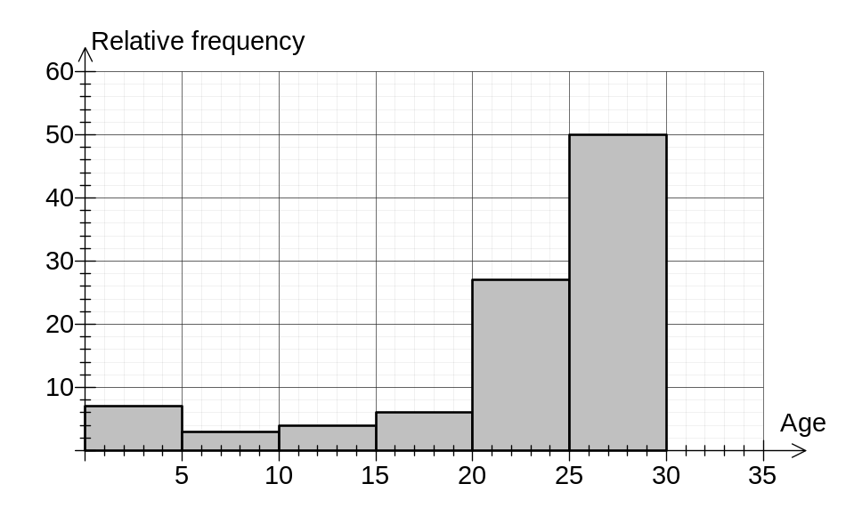

(f) Compare these two datasets using the mean and standard deviation and also noting any other similarities or differences. (3 marks)
The mean age of U30's in West Perth is much higher than that for WA as a whole (21.8 compared to 14.9 years).

The spread of ages is fairly similar for both datasets when comparing standard deviations (8.66 compared to 7.49).

However, a major difference is that the WA data is evenly spread whereas the W Perth data is densely clustered in the older age groups.

Question 13 (6 marks)
The table below shows the cost, in thousands of dollars, to install underground cables directly between the six locations A, B, C, D, E and F.

 | A | B | C | D | E | F
A | - | 50 | - | 25 | - | 45
B | 50 | - | 45 | - | - | -
C | - | 45 | - | - | 40 | 30
D | 25 | - | - | - | 45 | 40
E | - | - | 40 | 45 | - | 35
F | 45 | - | 30 | 40 | 35 | -

(a) Draw a network diagram to show this information. (3 marks)

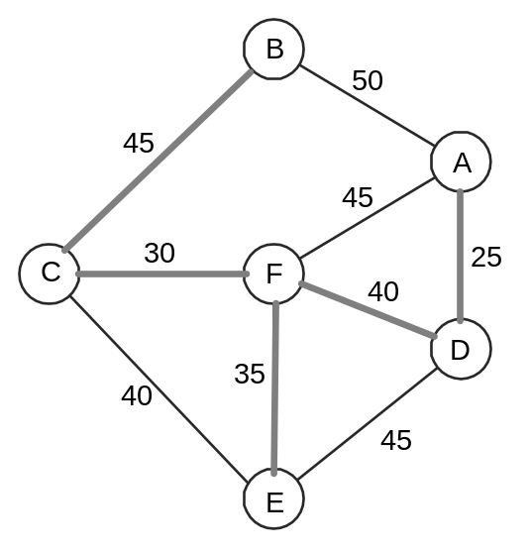

(b) Show the minimum spanning tree for this network on the diagram above and hence determine the cost of installing cables along the minimum spanning tree. (3 marks)

AD - 25
DF - 40
FE - 35
FC - 30
CB - 45

Total 175

Minimum Cost is $175 000

Question 14 (8 marks)
(a) The girth of a tree increases by 30 cm in the first year, 27 cm in the second year, 24.3 cm in the third year and so on, with the increase in girth forming a geometric sequence.

(i) How much does the girth increase in the fourth year? (2 marks)

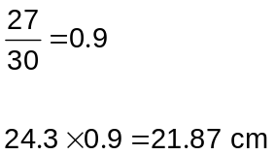

(ii) Write a recursive rule for 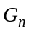, the increase in girth of the tree in year . (2 marks)
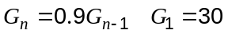

(b) The number of new trees planted in an orchard in year , 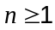, is given by the rule 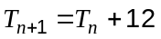, 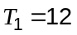.

(i) How many new trees were planted in the third year? (1 mark)
36 trees

Each year, new trees are planted as described above and the five worst trees are cut down and removed. At the start of the first year, there were 240 trees in the orchard.

(ii) How many trees were in the orchard at the start of the second year? (1 mark)
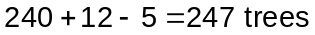

(iii) How many trees were in the orchard at the start of the fourth year? (2 marks)
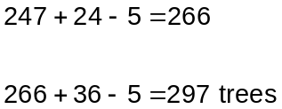

Question 15 (7 marks)
Fuel can flow from a tank at T to a power station at P through a network of pipes as shown below. The number on each arc represents the maximum amount of fuel, in kL, that can flow through that pipe every hour.

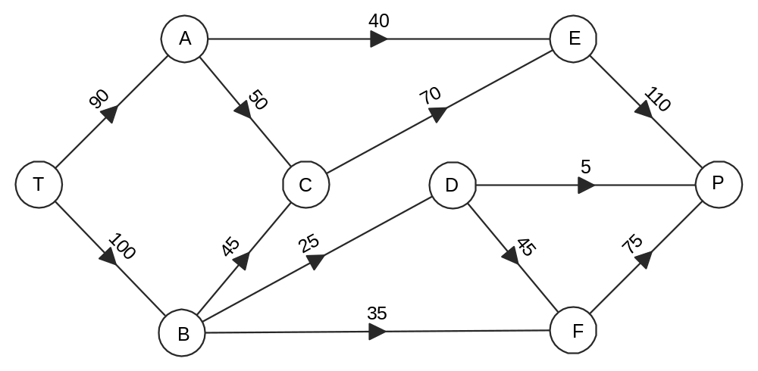

(a) What is the maximum amount of fuel that can flow from the tank to the power station every hour? Show use of systematic working. (5 marks)
TAEP - 40
TACEP - 50
TBCEP - 20
TBDP - 5
TBDFP - 20
TBFP - 35

Total - 170 kL per hour

(b) An engineer has suggested building an additional pipe from C to D with a maximum flow rate of 30 kL per hour. What effect, if any, would this have on your answer to (a)?
(2 marks)
Increase max flow by 20 kL per hour.

(Along path TBCDFP)

Question 16 (9 marks)
Data measured in 2004 from nine countries is shown in the table below. Researchers were looking for a relationship between average income per person (, in thousands of US dollars per year) and the average sugar consumption (, in g per day) of people from various countries.

Country | Austria | Canada | India | Iran | Russia | S. Africa | S. Korea | Thailand | Turkey
($000/y) | 33.5 | 34.3 | 2.0 | 10.3 | 11.1 | 8.2 | 20.4 | 6.6 | 7.4
(g/day) | 123 | 173 | 66 | 71 | 121 | 90 | 99 | 88 | 66

(a) Plot this data on the scatter plot below. (3 marks)
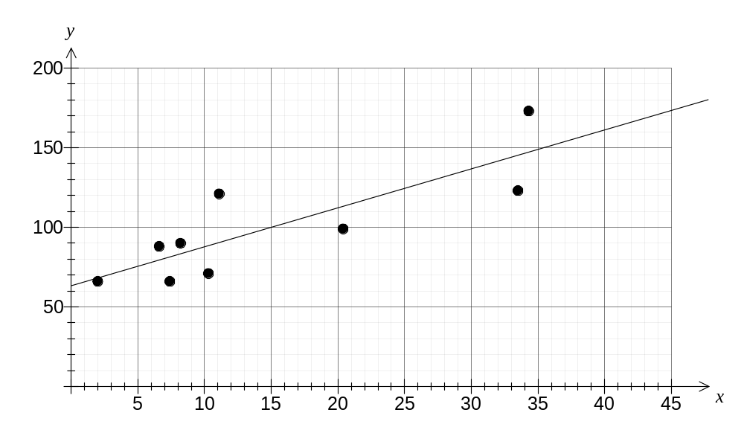
(b) Fit a trend line to your graph. (2 marks)

(c) Estimate the daily sugar consumption for

(i) Australia, which had an average income of US$32 100 in 2004. (1 mark)

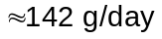

(ii) USA, which had an average income of US$41 000 in 2004. (1 mark)
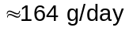

(d) Explain which of the two estimates in (c) you are more confident about and explain why.
(2 marks)
More confident about the estimate for Australia, as the estimate for USA involves extrapolation and so is unreliable.

Question 17 (9 marks)
A student made a spinner in the shape of a regular octagon and marked it with the letters A and B as shown. | 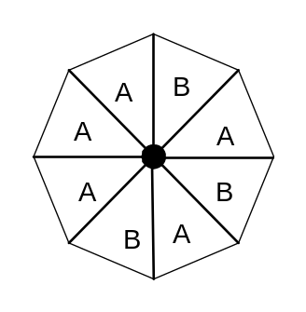

(a) What is the theoretical probability of the spinner landing on an A? (1 mark)

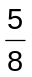

The student then spun the spinner 32 times and noted the letter that it came to rest on, recording each result in the table below.

Number of A's | 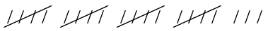
Number of B's | 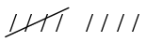

(b) How many A's would be expected for this many spins and how many were actually spun?
(2 marks)
Expect 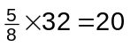A's

Actual number of A's is 23

(c) Is the likely reason the actual and expected number of A's in (b) is different because of a poorly made spinner? Explain your answer. (2 marks)
No. With only a small number of trials of the spinner, it is unlikely that the actual and expected number would be very close to each other.

The student then simulated the experiment using a list of 50 random digits shown here.

62874 18969 37901 72745 75459 47736 32289 72731 08134 41063

Let the digits 1, 2, 3, 4 and 5 represent an A being spun and the digits 6, 7 and 8 represent a B. Ignore the digits 0 and 9.

(d) How many B's were spun in the first five simulations? (1 mark)
3

(e) How many simulations are possible with the list of random numbers shown? (1 mark)
42

(f) Use the list of random digits to simulate the experiment and use your results to determine the percentage of simulations that the spinner stopped on a B. (2 marks)
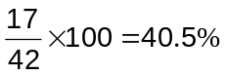

Question 18 (10 marks)
A sketch (not to scale) of a block of land is shown below, with angles in degrees and lengths in metres.
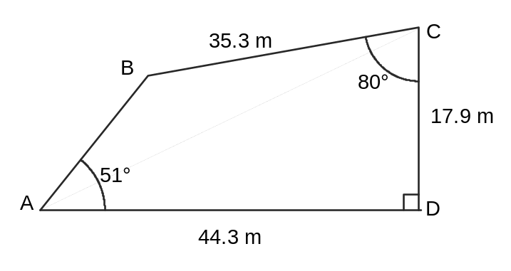
(a) Add the straight line AC to the diagram and then use the tangent ratio to show that the size of angle  is 22°. (2 marks)
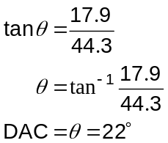

(b) Determine the size of angle 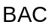 and the size of angle . (2 marks)
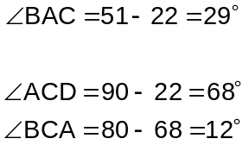

(c) Use trigonometry to calculate the distance AB, rounding your answer to three significant figures. (3 marks)
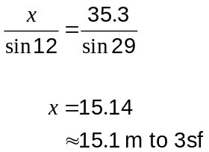

(d) Calculate the area of the block of land. (3 marks)
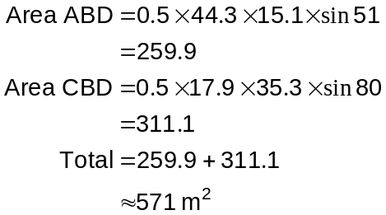

Additional working space

Question number: _________

Additional working space

Question number: _________

Additional working space

Question number: _________

This examination paper may be freely copied, or communicated on an intranet, for non-commercial purposes within educational institutes that have purchased the paper from WA Examination Papers provided that WA Examination Papers is acknowledged as the copyright owner. Teachers within purchasing schools may change the paper provided that WA Examination Paper's moral rights are not infringed.

Copying or communication for any other purposes can only be done within the terms of the Copyright Act or with prior written permission of WA Examination papers.

Published by WA Examination Papers
PO Box 445 Claremont WA 6910

